Harmonious Echoes: An Enchanting Evening of Chinese Music at St. Swiss in London

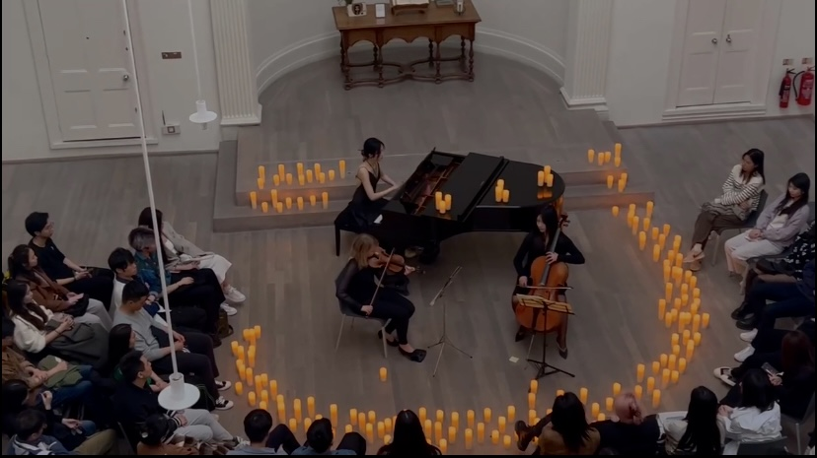
London, a city renowned for its cultural diversity and artistic vibrancy, delivered a mesmerizing performance on 29 April at the esteemed St. Swiss Church in London. With violinist Sonja Tuomela, cellist Fei (Christina) Pu and pianist Yuting (Kris) Liang, the Candlelight Concert: Jay Chou & JJ Lin transcended geographical boundaries and transported the audience to the mesmerizing realm of Chinese pop music.

The atmosphere brimmed with palpable anticipation, as both music enthusiasts and curious minds congregated with eager hearts. The venue's historical aura served as the perfect canvas for the auditory tapestry poised to unfold. An exquisite fusion of Chinese-style music woven with the harmonies of Western instruments resonated deeply within the souls of all in attendance.

What set this concert apart was the seamless interplay between the performers and their audience. As the evocative strains of Chinese melodies wafted through the air, an unspoken harmony emerged, inspiring the audience to become an integral part of the performance. Voices intertwined in melodic unison, blurring the demarcation between the stage and the audience, thereby forging an unbreakable bond of unity and cultural exchange.

The performers exuded an infectious passion and joy, mirrored by the enthusiastic engagement of the audience. A vivid testament to the potency of music transcending linguistic and cultural barriers, the performance served as a bridge uniting individuals from diverse backgrounds in a harmonious celebration of artistic expression.

In essence, this event celebrated culture and underscored the unifying potency of music. The resonance of these harmonious melodies continues to reverberate, a reminder of the enduring impact of cultural exchange and artistic expression on our lives.

